Assignment 5: Student Marking Write Up

The goal of my program was to give the user as much control as possible to get information on the data that they want. The first thing you do is click the Student Marking tab, then click the button. Once that happens, a user form will show up. Click browse, and select the Registrar.accbdb file. You will then see the course codes fill up in the courses list box. Graphical user interface

Select a course, and click import students to create a sheet with a class list, or import grades that will import a sheet with all the grades of the assignments, labs, and exams. The program will also calculate each individual student's final grade and output it on the appropriate sheet. Click next to pull up the next form.

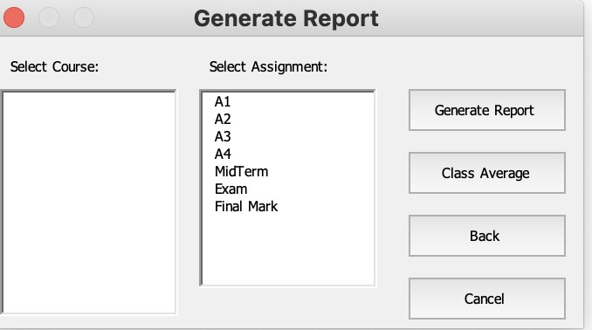

Select a course and click the class average button. A message box will appear with the class average. Select a course and select an assignment, then click “Generate Report. A table with the min, max, average, and standard deviation of all grades will be outputted on the respective sheet. A histogram of the grade distribution will also be created and put on the respective sheet. A word document will also be generated with the table and the histogram.

\*\*\*\* NOTE: I wrote this program on my Windows computer but wrote this writeup on my Mac. The user forms will look slightly different on Windows compared to Mac.